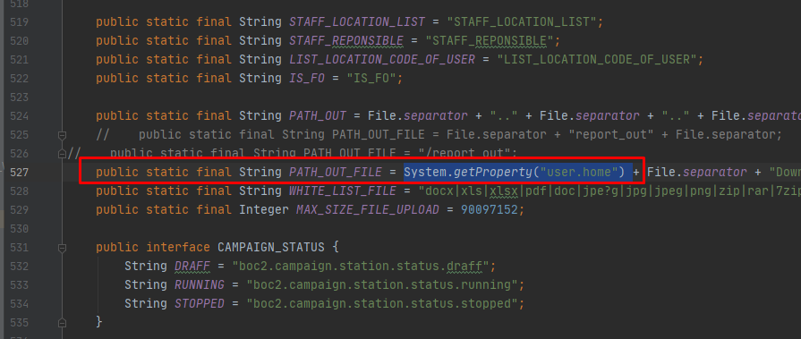

In wwindow, to see what is that: type in cmd: **echo %userprofile% -> return: C:\Users\Administrator**

In linux, type: **eval echo ~$USER -> return: /home/app**